Polygon–Circle Tangency

Definition
# Source: AI Source: Provided by: [Data Path: Persons Table -> ID Column: 1, Name_En Column: Motasem Essam] -> From: [ChatGPT] on [7/25/2026]
Polygon–Circle Tangency is the relationship in which a circle touches one or more sides of a polygon at specific points called Tangency Points or Points of Tangency.
When a circle touches every side of a polygon, the circle is called an inscribed circle, and the polygon is called a tangential polygon.
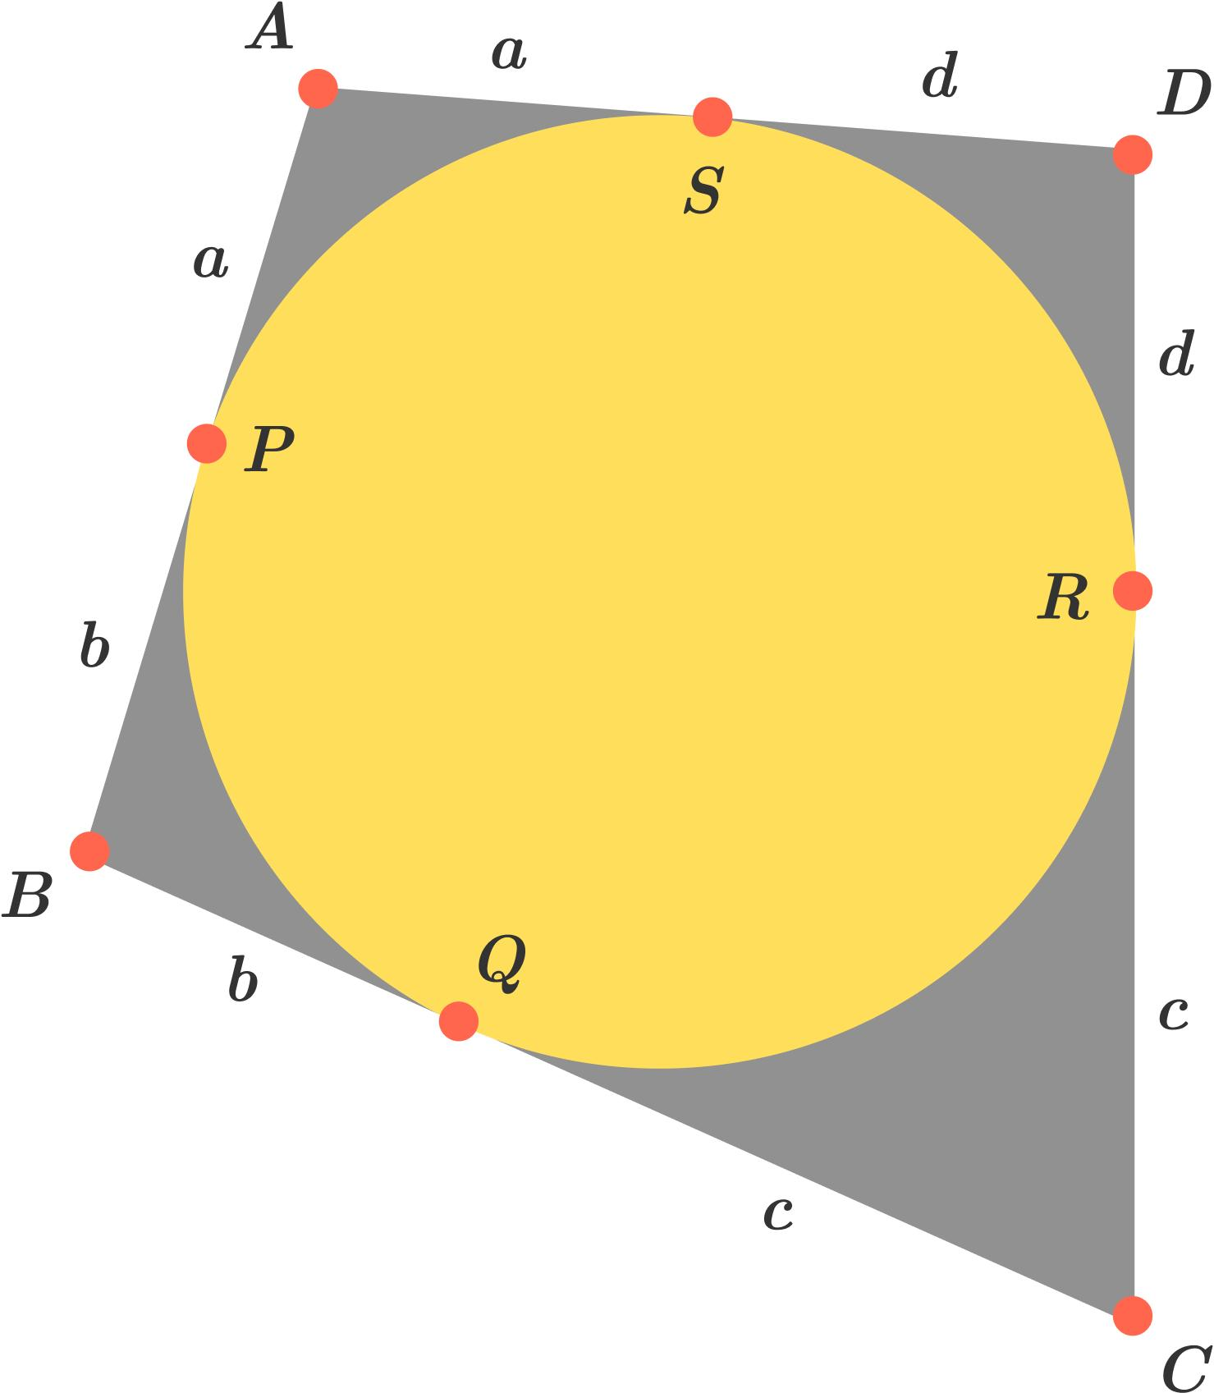
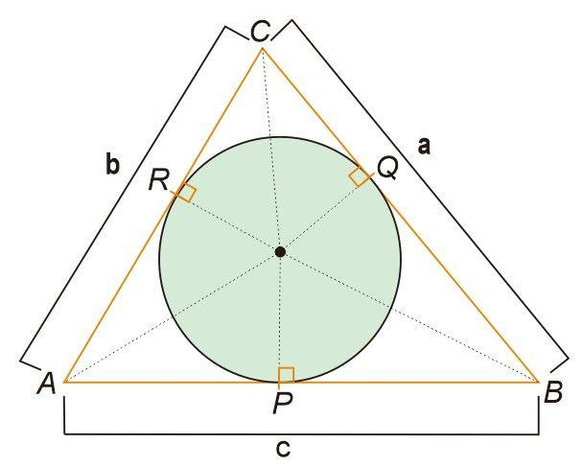
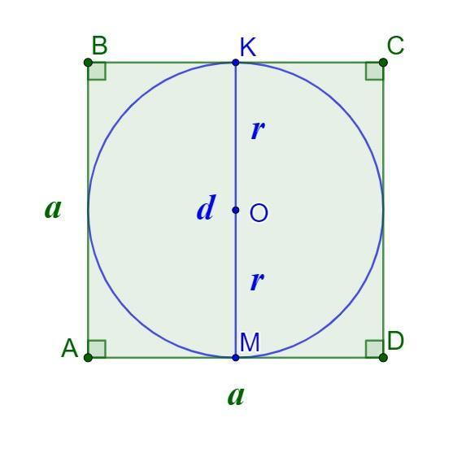
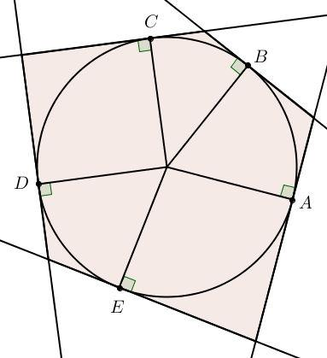
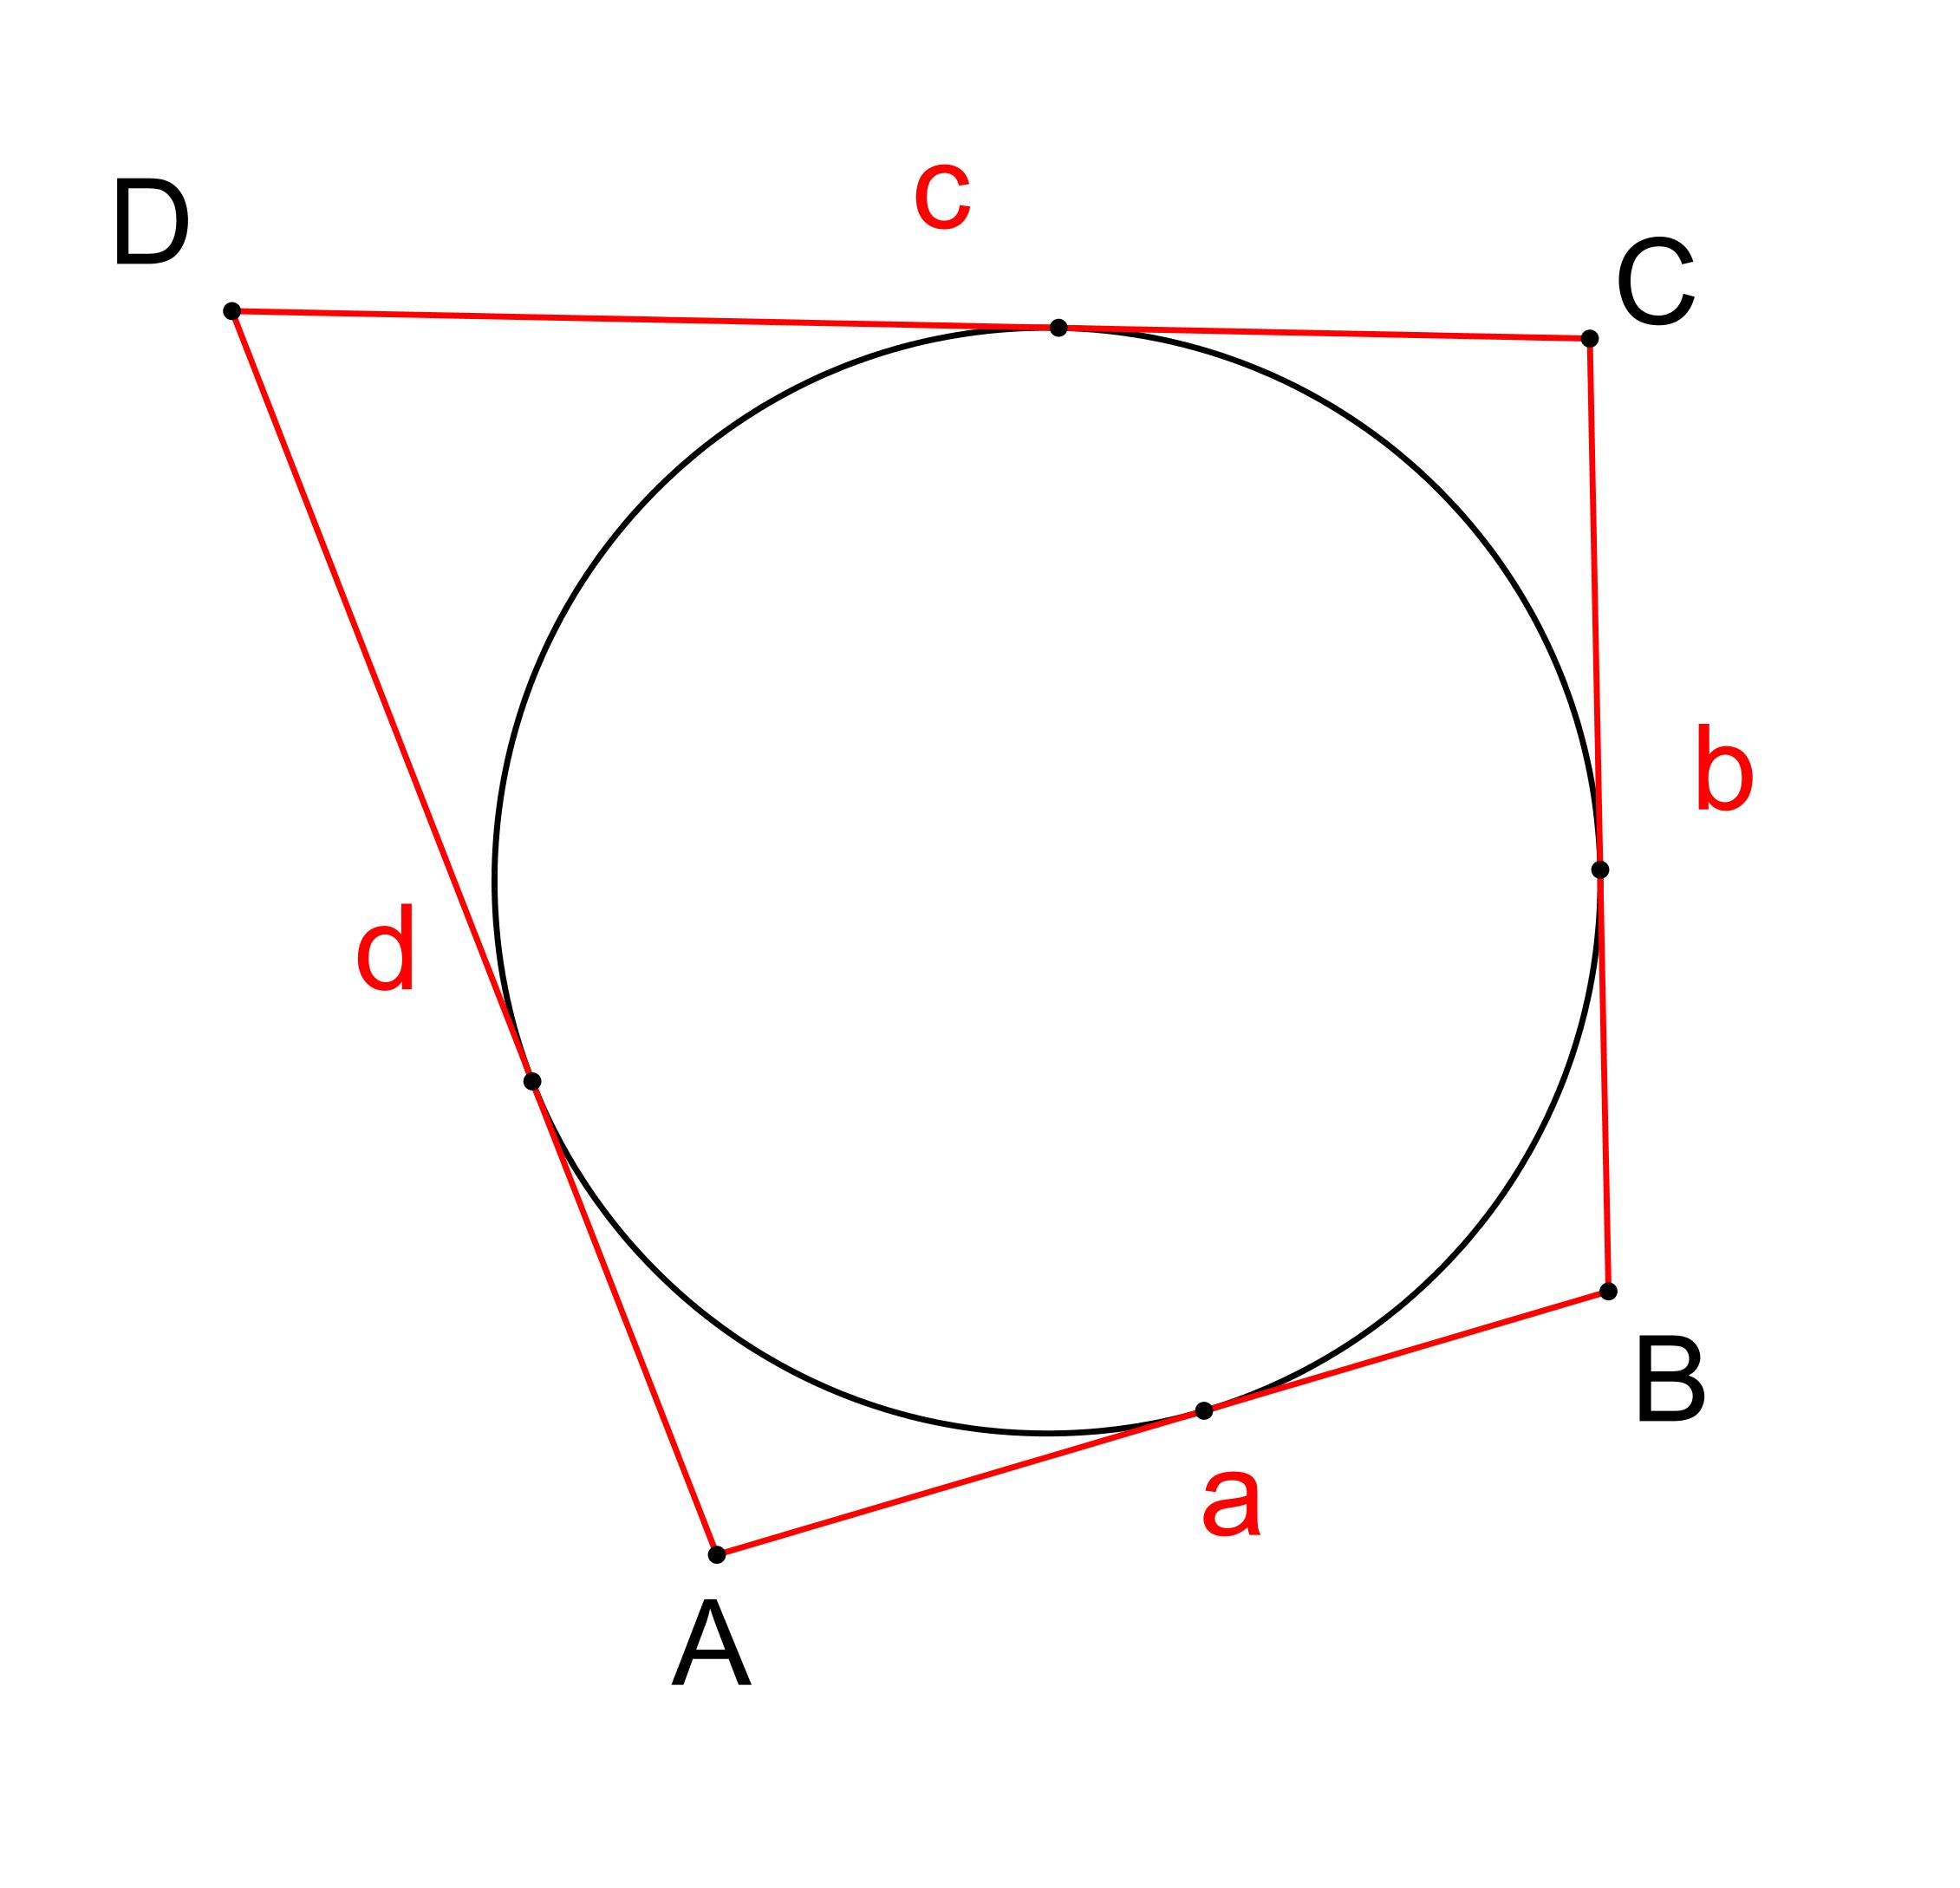
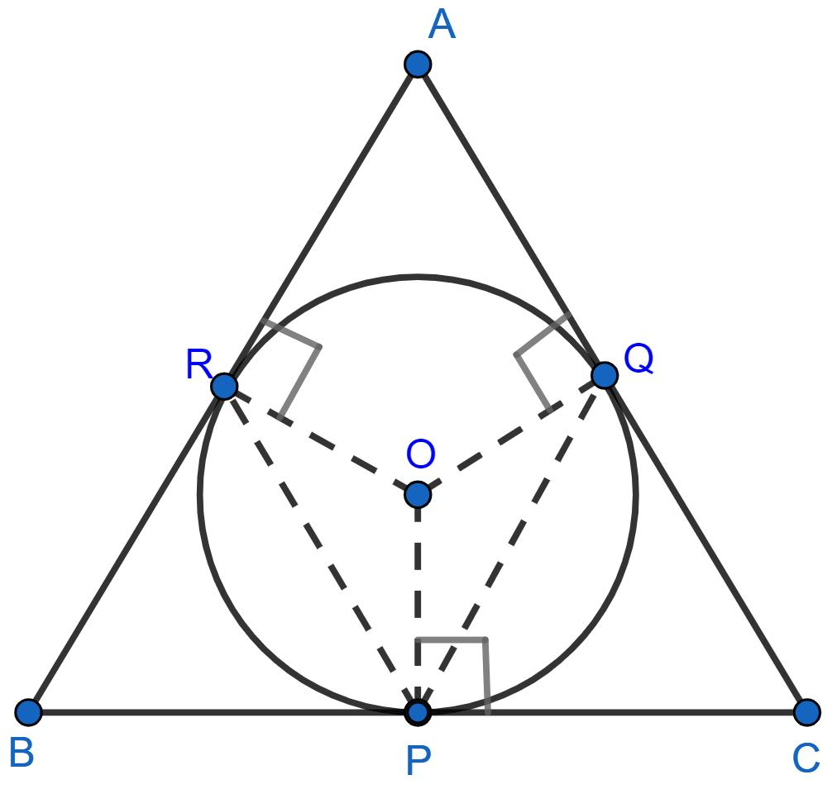

Fundamental Concept
# Source: AI Source: Provided by: [Data Path: Persons Table -> ID Column: 1, Name_En Column: Motasem Essam] -> From: [ChatGPT] on [7/25/2026]
Consider a polygon containing a circle.
If the circle touches a side at $T$, then $T$is the tangency point:
$$\boxed{T∈\text{side of polygon}}$$
and:
$$\boxed{T∈\text{circle}}$$
At the tangency point, the radius from the circle's center to $T$is perpendicular to the polygon side:
$$\boxed{OT⊥\text{side}}$$
Therefore, the perpendicular distance from the center to the side equals the circle's radius.

Types of Polygon–Circle Tangency
# Source: AI Source: Provided by: [Data Path: Persons Table -> ID Column: 1, Name_En Column: Motasem Essam] -> From: [ChatGPT] on [7/25/2026]

Polygon–Circle Tangency
├── Single-Side Tangency
├── Multiple-Side Tangency
└── Complete Polygon–Circle Tangency
└── Circle Tangent to Every Side
The most important case is complete tangency, where the circle touches every side of the polygon.

Single-Side Tangency
# Source: AI Source: Provided by: [Data Path: Persons Table -> ID Column: 1, Name_En Column: Motasem Essam] -> From: [ChatGPT] on [7/25/2026]
A circle can touch a polygon at only one side.
The point where the circle touches that side is a tangency point.
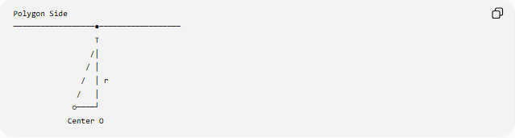
Polygon Side
──────────────────●──────────────────
T
/│
/ │
/ │ r
/ │
○────┘
Center O
The radius satisfies:
$$\boxed{OT⊥\text{side}}$$
This is the same radius–tangent relationship found in line–circle tangency.

Multiple-Side Tangency
# Source: AI Source: Provided by: [Data Path: Persons Table -> ID Column: 1, Name_En Column: Motasem Essam] -> From: [ChatGPT] on [7/25/2026]
A circle can touch several sides of the same polygon.
For example, a circle inside a polygon might touch three, four, or more sides.
Each contact produces a separate tangency point.
If the circle touches sides $AB$, $BC$, and $CD$at $T_{1},T_{2},T_{3}$:
$$T_{1}∈AB \\ T_{2}∈BC \\ T_{3}∈CD$$
and:
$$OT_{1}⊥AB \\ OT_{2}⊥BC \\ OT_{3}⊥CD$$

Complete Polygon–Circle Tangency
# Source: AI Source: Provided by: [Data Path: Persons Table -> ID Column: 1, Name_En Column: Motasem Essam] -> From: [ChatGPT] on [7/25/2026]
A circle is inscribed in a polygon when it lies inside the polygon and touches every side.
The polygon is then called a tangential polygon.
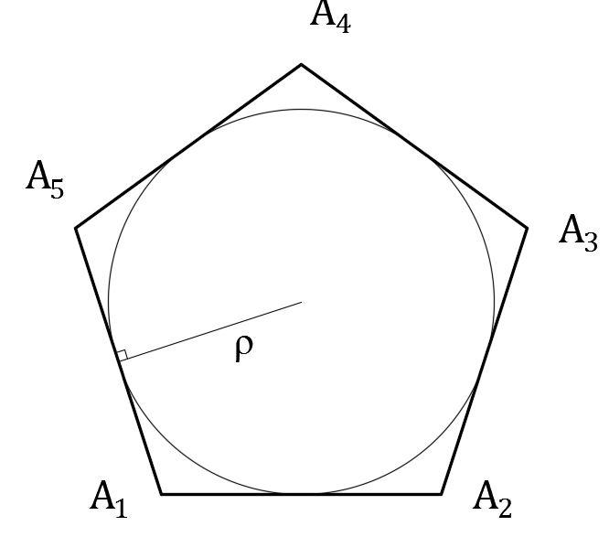
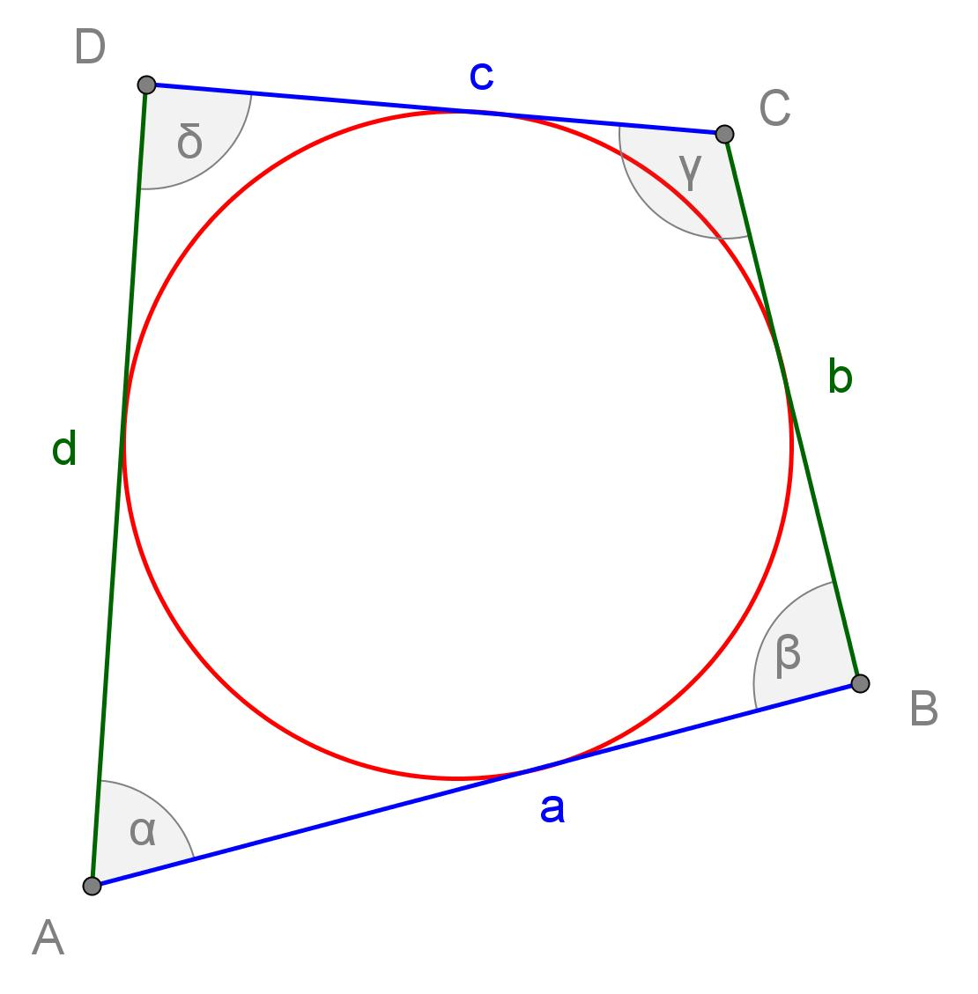
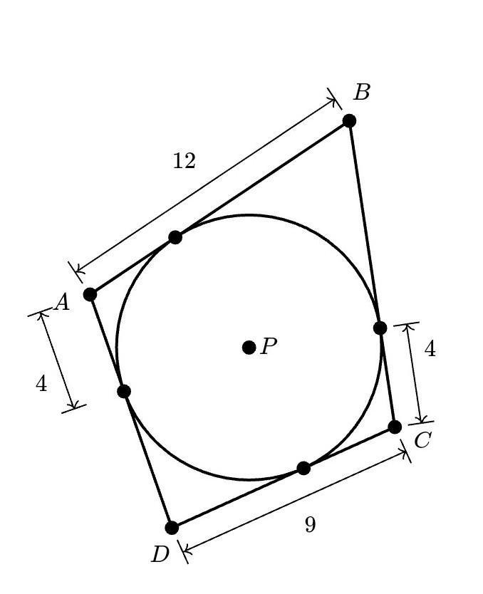
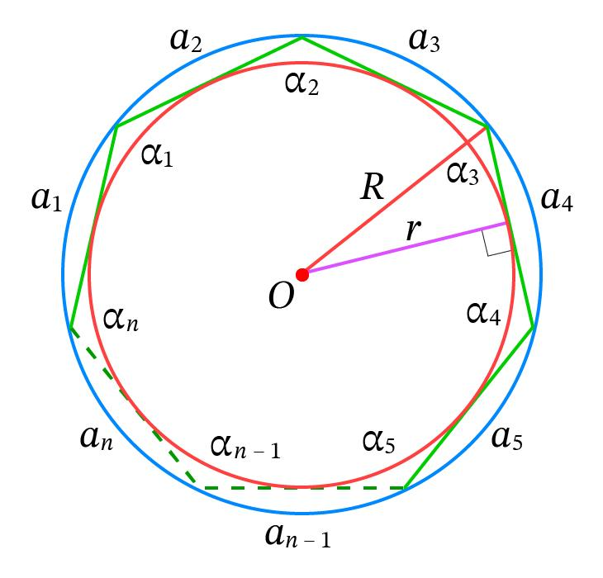
For an $n$-sided tangential polygon, the circle has $n$tangency points, one on each side, assuming each side is touched at one point.

Tangency Points of an Inscribed Circle
# Source: AI Source: Provided by: [Data Path: Persons Table -> ID Column: 1, Name_En Column: Motasem Essam] -> From: [ChatGPT] on [7/25/2026]
Suppose a circle with center $O$is tangent to the sides of polygon $ABCDE$.
Let the tangency points be:
$$T_{1},T_{2},T_{3},T_{4},T_{5}$$
Then:
$$T_{1}∈AB \\ T_{2}∈BC \\ T_{3}∈CD \\ T_{4}∈DE \\ T_{5}∈EA$$
Every radius to a tangency point is perpendicular to its corresponding side.

Polygon–Circle Tangency in a Triangle
# Source: AI Source: Provided by: [Data Path: Persons Table -> ID Column: 1, Name_En Column: Motasem Essam] -> From: [ChatGPT] on [7/25/2026]
The most familiar example is an incircle.
A triangle has three sides, so its incircle touches the three sides at three tangency points.
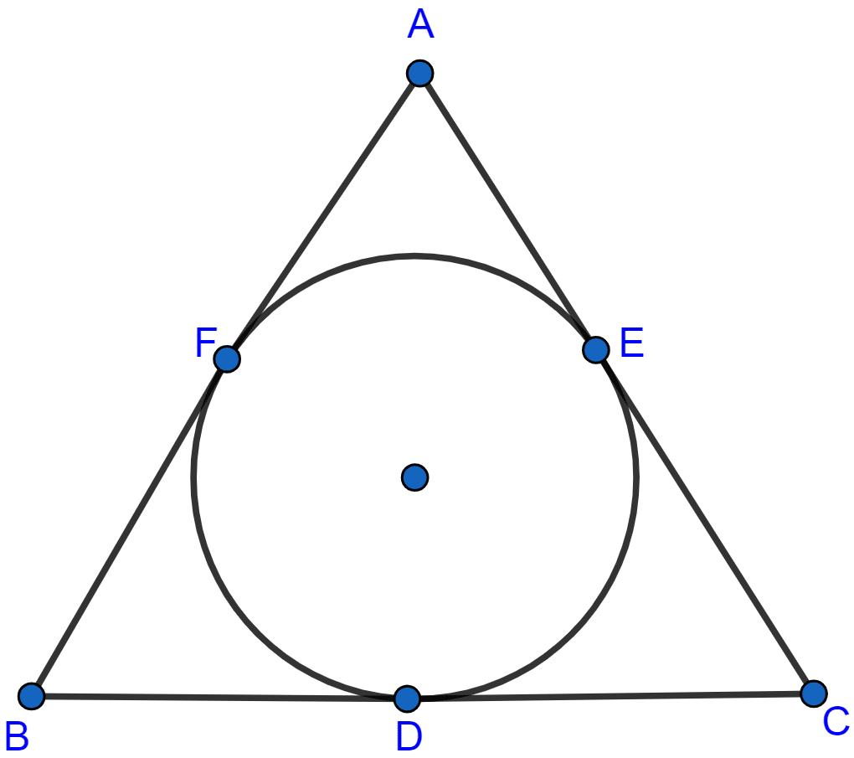
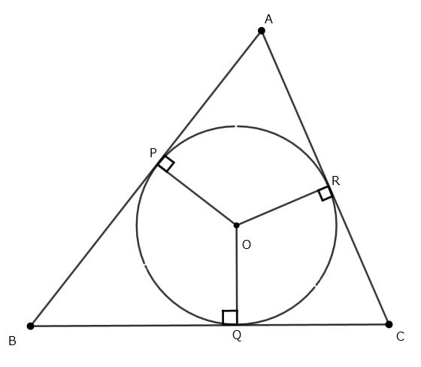
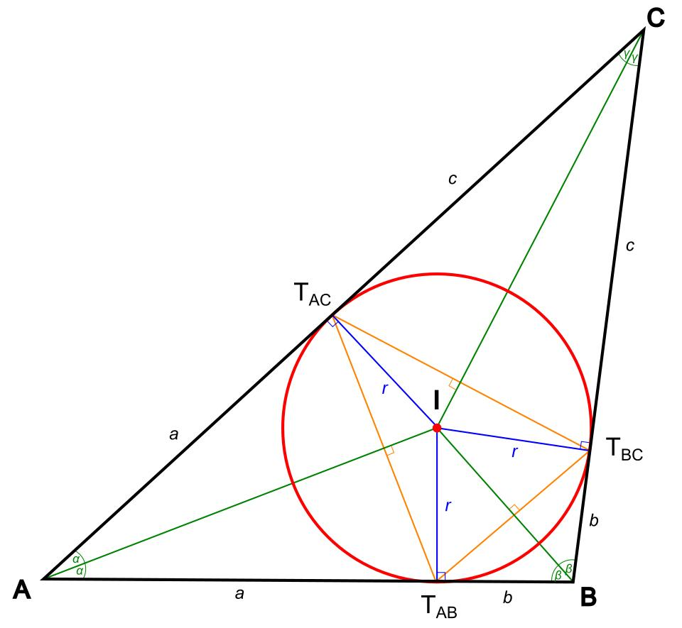
If the triangle is $ABC$, and the tangency points are $D,E,F$:
$$D∈AB \\ E∈BC \\ F∈CA$$
The incenter $I$satisfies:
$$ID⊥AB \\ IE⊥BC \\ IF⊥CA$$
and:
$$\boxed{ID=IE=IF=r}$$
where $r$is the inradius.

Equal Tangent Segments in a Polygon
# Source: AI Source: Provided by: [Data Path: Persons Table -> ID Column: 1, Name_En Column: Motasem Essam] -> From: [ChatGPT] on [7/25/2026]
An important property of tangency points is that tangent segments drawn from the same external vertex are equal.
For a triangle with incircle:

A
/ \
D F
/ \
B---E---C
From vertex $A$:
$$\boxed{AD=AF}$$
From vertex $B$:
$$\boxed{BD=BE}$$
From vertex $C$:
$$\boxed{CE=CF}$$
This property applies generally to tangent segments from the same external point.

Tangency in a Quadrilateral
# Source: AI Source: Provided by: [Data Path: Persons Table -> ID Column: 1, Name_En Column: Motasem Essam] -> From: [ChatGPT] on [7/25/2026]
A quadrilateral can have a circle tangent to all four sides.
Such a quadrilateral is called a tangential quadrilateral.
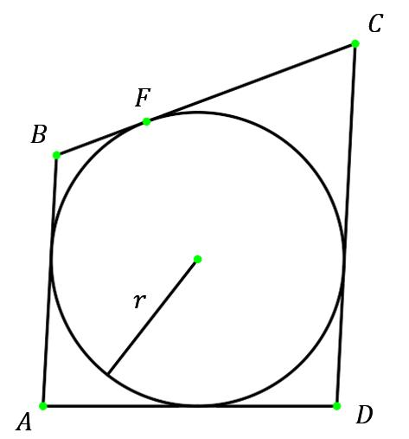
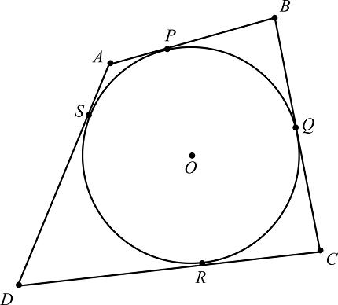
If the tangency points are $E,F,G,H$, then each side is divided into two tangent segments.
For vertices $A,B,C,D$:
$$AE=AH \\ BE=BF \\ CG=CF \\ DG=DH$$
A tangential quadrilateral satisfies the Pitot theorem:
$$\boxed{AB+CD=BC+DA}$$
for the side lengths.

Regular Polygon–Circle Tangency
# Source: AI Source: Provided by: [Data Path: Persons Table -> ID Column: 1, Name_En Column: Motasem Essam] -> From: [ChatGPT] on [7/25/2026]
Every regular polygon has a natural inscribed circle.
For a regular polygon:
- The circle's center is the polygon's center.
- The circle touches every side.
- Each radius to a tangency point is perpendicular to the corresponding side.
- The tangency points are symmetrically distributed.
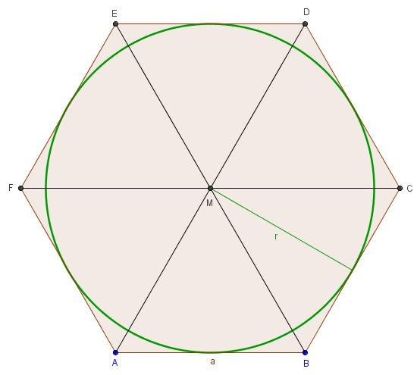
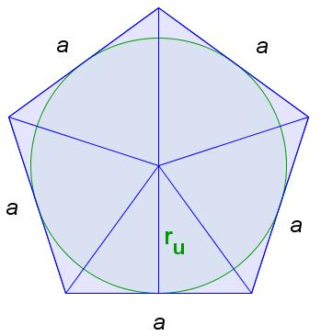
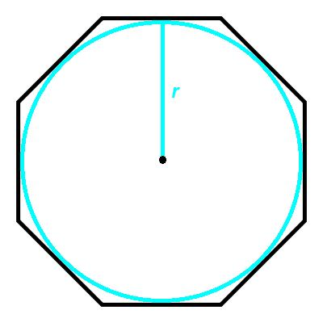
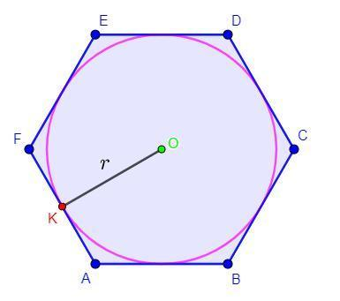
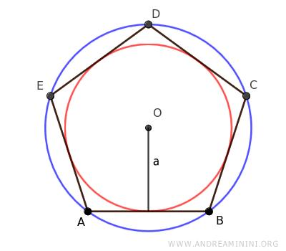
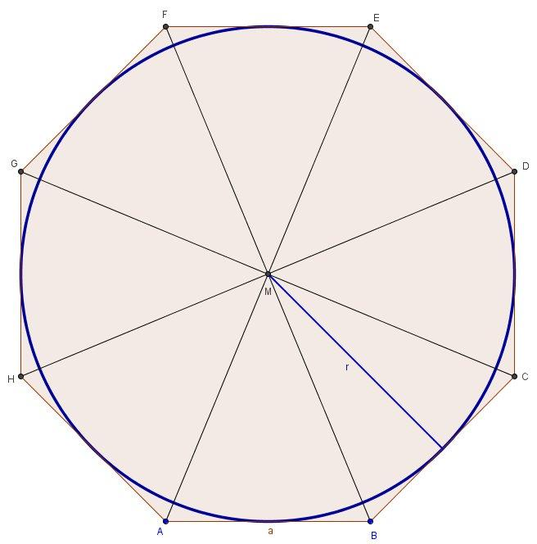
The radius of this circle is equal to the polygon's apothem:
$$\boxed{r=a_{p}}$$
where $a_{p}$denotes the apothem.
The area of a regular polygon can therefore be written:
$$\boxed{A=\frac{1}{2}Pr}$$
where:
- $P$= perimeter
- $r$= inradius

Tangency Point and Apothem
# Source: AI Source: Provided by: [Data Path: Persons Table -> ID Column: 1, Name_En Column: Motasem Essam] -> From: [ChatGPT] on [7/25/2026]
In a regular polygon, the segment from the center perpendicular to a side is both:
- the apothem, and
- the radius to the tangency point.
Therefore:
$$\boxed{\text{apothem}=\text{inradius}}$$
At a tangency point $T$:
$$OT⊥\text{side}$$
and:
$$OT=r$$

Tangency Point and Polygon Vertex
# Source: AI Source: Provided by: [Data Path: Persons Table -> ID Column: 1, Name_En Column: Motasem Essam] -> From: [ChatGPT] on [7/25/2026]
A tangency point normally lies on a side, rather than at a vertex.
For example:
$$T∈\overset{‾}{AB}$$
means that $T$lies somewhere on side $AB$.
The circle is tangent to the side at $T$, while the polygon's vertices remain distinct from $T$in the ordinary case.

Tangency Point and Side Division
# Source: AI Source: Provided by: [Data Path: Persons Table -> ID Column: 1, Name_En Column: Motasem Essam] -> From: [ChatGPT] on [7/25/2026]
When a circle is tangent to two sides meeting at the same vertex, the two tangent segments from that vertex are equal.
If a circle touches $AB$at $T_{1}$and $AC$at $T_{2}$:
$$\boxed{AT_{1}=AT_{2}}$$
This is useful for determining unknown side lengths.

Number of Tangency Points
# Source: AI Source: Provided by: [Data Path: Persons Table -> ID Column: 1, Name_En Column: Motasem Essam] -> From: [ChatGPT] on [7/25/2026]
If a circle is tangent to every side of a simple $n$-sided polygon, there is normally one tangency point per side.
Therefore:
$$\boxed{\text{Number of tangency points}=n}$$
Examples:
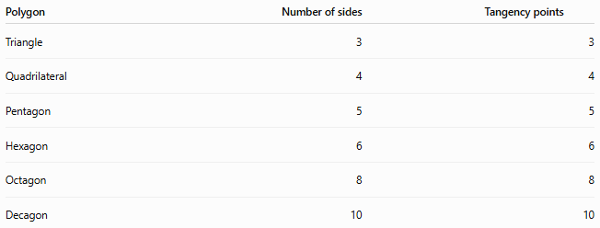
Polygon | Number of sides | Tangency points
Triangle | 3 | 3
Quadrilateral | 4 | 4
Pentagon | 5 | 5
Hexagon | 6 | 6
Octagon | 8 | 8
Decagon | 10 | 10

Polygon–Circle Tangency vs. Circumscribed Circle
# Source: AI Source: Provided by: [Data Path: Persons Table -> ID Column: 1, Name_En Column: Motasem Essam] -> From: [ChatGPT] on [7/25/2026]
These two concepts should not be confused.
Polygon with an Inscribed Circle
The circle is inside the polygon and touches its sides.
$$\boxed{\text{Circle tangent to sides}}$$
The polygon is tangential.
Polygon Inscribed in a Circle
The polygon is inside the circle and its vertices lie on the circle.
$$\boxed{\text{Vertices lie on circle}}$$
The polygon is cyclic.
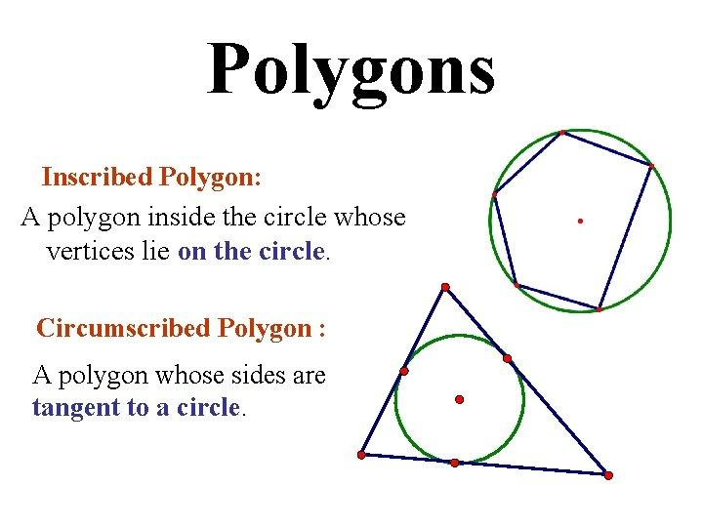
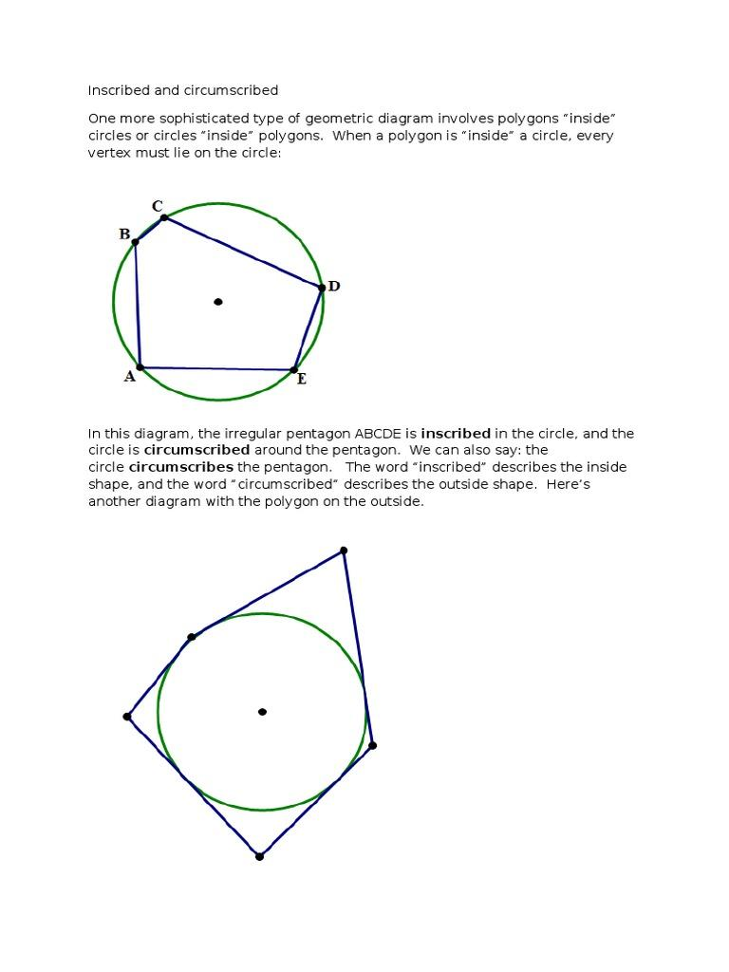
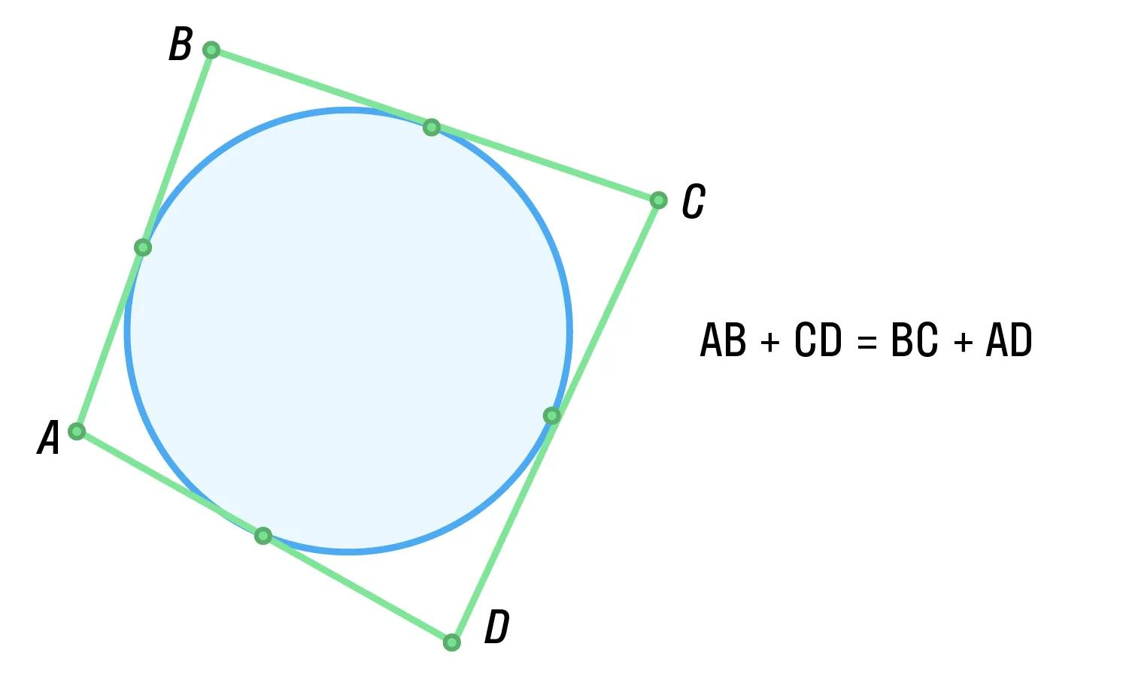

Comparison
# Source: AI Source: Provided by: [Data Path: Persons Table -> ID Column: 1, Name_En Column: Motasem Essam] -> From: [ChatGPT] on [7/25/2026]
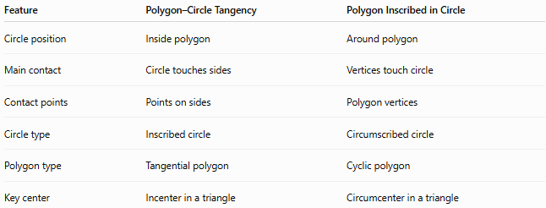
Feature | Polygon–Circle Tangency | Polygon Inscribed in Circle
Circle position | Inside polygon | Around polygon
Main contact | Circle touches sides | Vertices touch circle
Contact points | Points on sides | Polygon vertices
Circle type | Inscribed circle | Circumscribed circle
Polygon type | Tangential polygon | Cyclic polygon
Key center | Incenter in a triangle | Circumcenter in a triangle

Important Properties
# Source: AI Source: Provided by: [Data Path: Persons Table -> ID Column: 1, Name_En Column: Motasem Essam] -> From: [ChatGPT] on [7/25/2026]
- A tangency point lies on both the circle and the corresponding polygon side.
- The radius to a tangency point is perpendicular to the side.
- A circle tangent to every side of a polygon is an inscribed circle.
- A polygon having an inscribed circle is called a tangential polygon.
- Tangent segments from the same polygon vertex are equal.
- Every regular polygon has an inscribed circle.
- In a regular polygon, the inradius equals the apothem.
- A tangential $n$-gon normally has one tangency point on each side.
- A triangle always has an incircle and therefore three tangency points.
- Tangential polygons should be distinguished from cyclic polygons.

Classification Tree
# Source: AI Source: Provided by: [Data Path: Persons Table -> ID Column: 1, Name_En Column: Motasem Essam] -> From: [ChatGPT] on [7/25/2026]
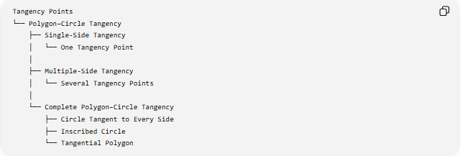
Tangency Points
└── Polygon–Circle Tangency
├── Single-Side Tangency
│ └── One Tangency Point
│
├── Multiple-Side Tangency
│ └── Several Tangency Points
│
└── Complete Polygon–Circle Tangency
├── Circle Tangent to Every Side
├── Inscribed Circle
└── Tangential Polygon
By Polygon
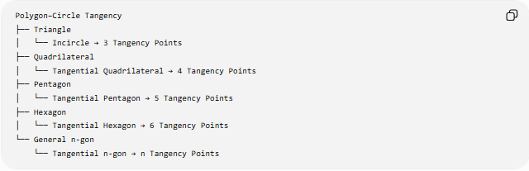
Polygon–Circle Tangency
├── Triangle
│ └── Incircle → 3 Tangency Points
├── Quadrilateral
│ └── Tangential Quadrilateral → 4 Tangency Points
├── Pentagon
│ └── Tangential Pentagon → 5 Tangency Points
├── Hexagon
│ └── Tangential Hexagon → 6 Tangency Points
└── General n-gon
└── Tangential n-gon → n Tangency Points

Key Formulas
# Source: AI Source: Provided by: [Data Path: Persons Table -> ID Column: 1, Name_En Column: Motasem Essam] -> From: [ChatGPT] on [7/25/2026]
Radius to Tangency Point
$$\boxed{OT⊥\text{side}}$$
Equal Tangent Segments
$$\boxed{AT_{1}=AT_{2}}$$
Tangential Quadrilateral
$$\boxed{AB+CD=BC+DA}$$
Regular Tangential Polygon
$$\boxed{A=\frac{1}{2}Pr}$$
Number of Tangency Points
$$\boxed{N=n}$$
for a circle tangent to all $n$sides.

Key Points
# Source: AI Source: Provided by: [Data Path: Persons Table -> ID Column: 1, Name_En Column: Motasem Essam] -> From: [ChatGPT] on [7/25/2026]
- Polygon–Circle Tangency occurs when a circle touches one or more polygon sides.
- Each contact point is a Tangency Point.
- At every tangency point, the radius is perpendicular to the polygon side.
- A circle tangent to every side is an inscribed circle.
- A polygon containing such a circle is a tangential polygon.
- Tangent segments from the same polygon vertex are equal.
- For a regular polygon, the inradius equals the apothem.
- A tangential $n$-gon normally has $n$tangency points when one circle touches every side.

